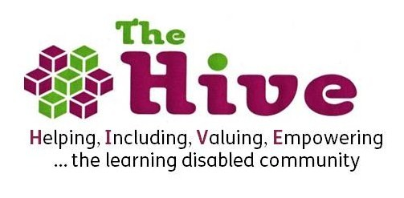
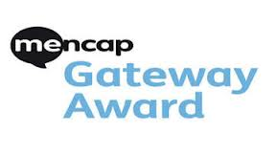

Gateway Award

Job role and Personal specification

Volunteer role: Gateway award Mentor

Responsible to: Gateway Officer

Hours: Hours as agreed with Gateway Officer

About the Award
The Gateway Award is an activity based award with the aims of building confidence and independence as well as encouraging people to try new things! It is a development opportunity for people with learning disabilities and is similar to The Duke of Edinburgh Award, with a bronze, silver and gold level.
The Award involves working on 5 different areas Hobbies, Fitness, Lifestyle, volunteering and a challenge. Each section (with the exception of the Gateway Challenge section) needs a specific number of hours completed which varies from level to level.
Gateway Award Mentors
You will be supporting participants to undertake the Gateway Award. This could take the form of a range of support. Primarily you will be encouraging participants to fill out their portfolio and plan their activities, and in some cases supporting them in undertaking an activity/activities.
Who will you support:
You will be assigned a participant or a number of participants to support, we will match you to a participant, or participants, who match you in terms of availability and interests. You will encourage and support them in filling out their portfolios, planning activities and reflecting on what they have done. You will also, if possible, support the participant/s in undertaking their chosen activities, if they require it. The level of support required from you will be based on what you have told us you can offer. This support can take place during day time evenings or weekends at times that are convenient to you and the participant, and will be decided upon between you, and the participant, with support from The Hive’s gateway Officer.

Volunteer Role

- encourage and support participants of the award to choose and plan activities
- help to complete forms and portfolio of evidence.
- If possible, support the participant/s in undertaking their chosen activities, if they require it.
- Work in accordance with The Hive’s principles, policies and Volunteer Handbook.
- Attend initial and ongoing training as required
- Record information in line with office procedures
- To meet with participants at various locations including at their homes.
- Assisting in various workshops on various life skills topics (optional)

Personal Specification

Attitudes and values

- Commitment to helping others take control of their lives
- Non Judgemental attitude
- Willing to challenge discrimination and prejudice
- Commitment to equal opportunities practice ie challenging racism, sexism, ageism and disability
- Commitment to client confidentiality
- Patience, sense of humour, reliability, commitment, enthusiasm

Skills and experience

- Experience working with people with learning disabilities
- Good listening and verbal communication skills
- Ability to assist and support people who may be disempowered or vulnerable
- Ability to assist and support people to speak up for themselves
- Interest in developing new skills.

